Student Name: Ahmed Basuony Abdelkader
Student ID: 2205124
The Report of GraphSAGE

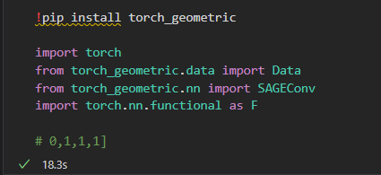
We install and import:
Torch for tensors, training and optimization
Torch_geometric.data to store the graph (nodes, edges, labels)
Torch_geometric.nn.SAGEConv the GraphSAGE layer
Torch.nn.functional as F for functional like relu, log_softmax and nll_loss

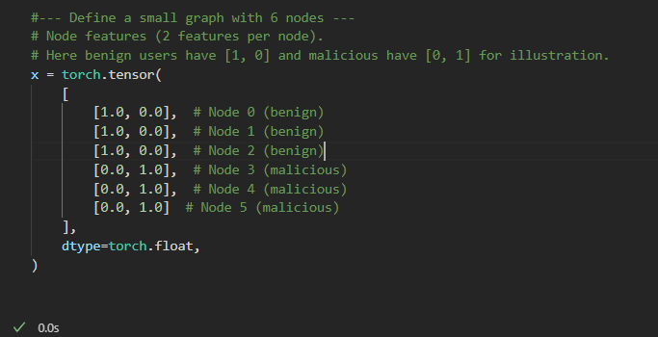
We create 6 nodes. Each node has a 2D feature vector:
-Benign users : [1.0, 0.0]
-Malicious users : [0.0, 1.0]
These features are stored in a tensor x with shape (6, 2) where
-Each row = one node
-Each column= one feature
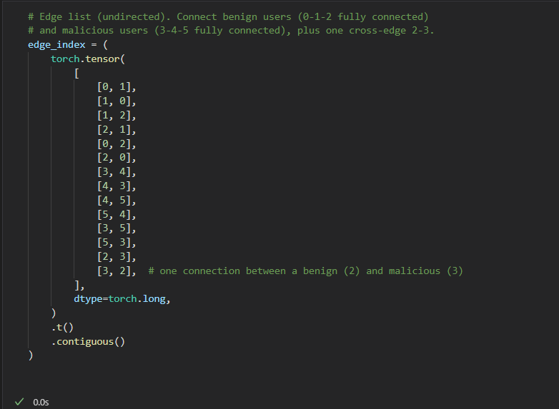
We define edge_index to describe how nodes are connected:
-Nodes 0, 1, 2 (benign) are fully connected to each other
-Nodes 3, 4, 5 (malicious) are fully connected to each other
There is one cross edge between node 2 and node 3 because the graph is treated as undirected, we add each edge in both directions 01and10
Edge_index ends up as a tensor of shape (2, num_edges):
First row= source nodes
Second row= target nodes

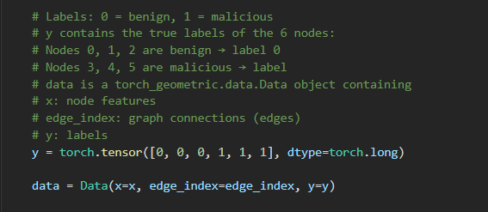
We assign labels:
-bengin0
-malicious1
So the label tensor y is : [0, 0, 0, 1, 1, 1]
Then we pack everything into a Data object:
-data.x node features
-data.edge_indexedges
-data.ylabels
This data object is what we pass to the mode

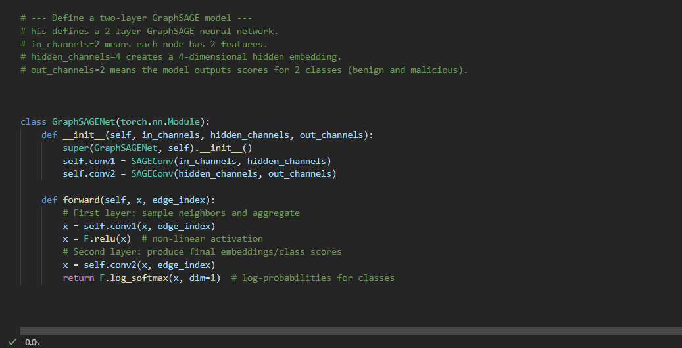
We define a class GraphSAGENet with 2 GraphSAGE layers:
-conv1= SAGEConv(in_channels, hidden_channels)
-conv2= SAGEConv(hidden_channels, out_channels)
In the forward method:
-First we apply conv1 and then F.reluthis gives hidden node representations
-Then we apply conv2this produces class scorce for each node
-Finally we apply F.log_softman(x, dim=1) to get log-probabilities over the 2 classes

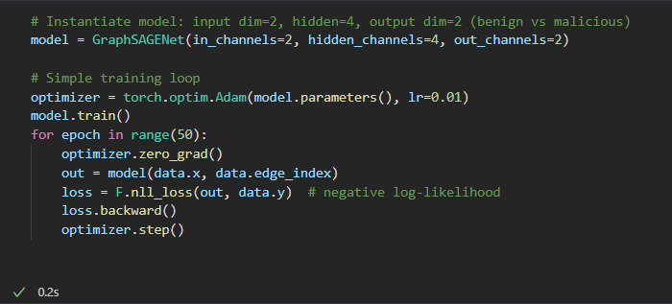
We create the mode with
-in_channels=2 because each node has 2 features
-hidden_channels=4
-out_channels=2 (benign vs malicious)
We use
Adam optimizer with learning rate 0.01 and A simple loop of 50 epochs
Each node:
Run the mode on data.x and data.edge_index
Compute the loss with F.null_loss(out, data.y)
Backprop with loss.backward()
Update weights with optimizer.step()

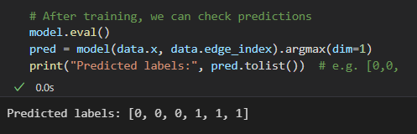
After training:
We switch to mode.level()
We run the model again and take argmax(dim=1) to get the predicted calss for each node
We print the predicted labels as a list.

